TITLE My First Program (Test.asm)

INCLUDE Irvine32.inc

.code

main PROC

mov eax, 10h

mov ebx, 25h

call DumpRegs

exit

main ENDP

END main

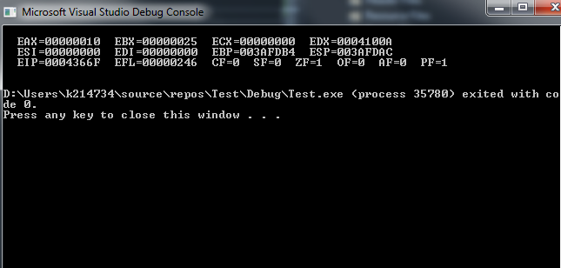

Q1 without 8500h

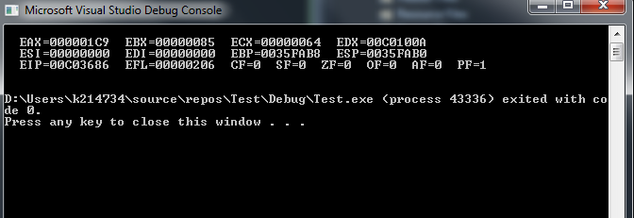

Q1 with 8500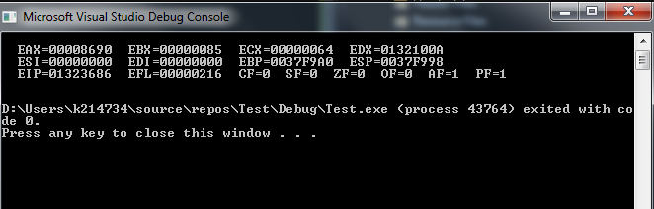

EAX = 7717342B EBX = 7EFDE000 ECX = 00000000 EDX = 00FF10AA ESI = 00000000 EDI = 00000000

EIP = 00FF3660 ESP = 003CFBF8 EBP = 003CFC00 EFL = 00000246

EAX = 00008500 EBX = 7EFDE000 ECX = 00000000 EDX = 00FF10AA ESI = 00000000 EDI = 00000000

EIP = 00FF3665 ESP = 003CFBF8 EBP = 003CFC00 EFL = 00000246

EAX = 00008500 EBX = 00000039 ECX = 00000000 EDX = 00FF10AA ESI = 00000000 EDI = 00000000

EIP = 00FF366A ESP = 003CFBF8 EBP = 003CFC00 EFL = 00000246

EAX = 00008500 EBX = 00000039 ECX = 00000060 EDX = 00FF10AA ESI = 00000000 EDI = 00000000

EIP = 00FF366F ESP = 003CFBF8 EBP = 003CFC00 EFL = 00000246

EAX = 00008539 EBX = 00000039 ECX = 00000060 EDX = 00FF10AA ESI = 00000000 EDI = 00000000

EIP = 00FF3671 ESP = 003CFBF8 EBP = 003CFC00 EFL = 00000206

EAX = 00008539 EBX = 00000039 ECX = 00000060 EDX = 00FF10AA ESI = 00000000 EDI = 00000000

EIP = 00FF3671 ESP = 003CFBF8 EBP = 003CFC00 EFL = 00000206

EAX = 00008599 EBX = 00000085 ECX = 00000060 EDX = 00FF10AA ESI = 00000000 EDI = 00000000

EIP = 00FF3678 ESP = 003CFBF8 EBP = 003CFC00 EFL = 00000206

EAX = 00008599 EBX = 00000085 ECX = 00000064 EDX = 00FF10AA ESI = 00000000 EDI = 00000000

EIP = 00FF367D ESP = 003CFBF8 EBP = 003CFC00 EFL = 00000206

EAX = 0000861E EBX = 00000085 ECX = 00000064 EDX = 00FF10AA ESI = 00000000 EDI = 00000000

EIP = 00FF367F ESP = 003CFBF8 EBP = 003CFC00 EFL = 00000206

EAX = 00008682 EBX = 00000085 ECX = 00000064 EDX = 00FF10AA ESI = 00000000 EDI = 00000000

EIP = 00FF3681 ESP = 003CFBF8 EBP = 003CFC00 EFL = 00000216

EAX = 00008682 EBX = 00000085 ECX = 00000064 EDX = 00FF10AA ESI = 00000000 EDI = 00000000

EIP = 00FF3686 ESP = 003CFBF8 EBP = 003CFC00 EFL = 00000216